
ABARILELA ELITE’S EXAMINATION BOARD (AEEBO)
PRIMARY SEVEN MOCK EXAMINATIONS 2024
ENGLISH
Time allowed: 2 hours 15 minutes

Index No.
Random No. |  |  |  |  |  | Personal No.

Name: ………………………………………………………………….……….………………..………………….
Signature: …………………………………………………………………….…………………………………….
School Random NO: ………………….……………………….….……………………………………..…….
District ID: ……………………………….….………………………………….………………………………..
Read the following instructions carefully:
FOR EXAMINERS’
USE ONLY
QN. NO. | MARKS | EXR’S NO
1 - 5
6 - 10
11 - 15
16 – 20
21 – 22
23 – 24
25 – 26
27 – 28
29 – 30
31 – 32
TOTAL

- Do not write your school or
District name anywhere on this paper.
2. This paper has two sections A and B. Section A has 50questions and section B has 5questions. This paper has 12 pages printed altogether.
3. Answer all questions. All the working for both sections
A and B must be shown in the spaces provided.
4. All working must be done using a blue or black ball point pen or ink. Any work done in pencil other than graphs and diagrams will N OT be marked?
5. No calculators are allowed in the examination room.
6. Unnecessary changes in your work and handwriting that cannot be easily ready may lead to loss of marks.
7. Do not fill anything in the box indicated: “For examiners’ use only” and the boxes inside the
Question paper.

©2024 Abarilela elites examination Board (AEEBO ) Turn Over first edition

Section A
In each of the questions 1 to 5, fill in the blank space with a suitable word.

1. Our elite’s family group has succeeded promoting girl child education.
2. The nursery pupils have shared orange among themselves.
3. is the second month of the year.
4. If you read hard, you will the examination.
5. The motorcyclist to you gave the letter has delivered it.

In each of the questions 6-15, use the correct form of the word given
in the brackets to complete the sentence.

6. Mary was dressed in her school uniform. (smart)
7. Mr. opio has a complicated (sign)
8. Hasifa is the of the three sisters. (old)
9. The mourners attended the of their friend. (bury)
10. shafula is a friend of (they)
11. The baker has much bread today. (sell)
12. My Mather bought two (radio)
13. As I was coming to school, I saw a goat (die)
14. One should not be when crossing the road. (care)
15. The work was done. (good)

In questions 16 and 17, arrange the given words in alphabetical order

16. mother, granny, friend, relative

17. prop, playwright, play, platform

In questions 18 and 19, use each of the given words in a sentence to show that you know the difference in their meaning.
18. son:
19. sun:

In questions 20 and 21, re-write the sentence, giving the opposite form of the underlined word.

20. The bridesmaid was very happy at the wedding.

First copy

In each of the questions 22 and 23, write the following in full.
22. shan’t:
23. St ___________________________________

In questions 24 to 26, re-write the sentences giving one word for the underlined group of words.
24. The secretary read the items to be discussed in a meeting to the members.

25. The cook served a meal eaten in the middle of the day.

26. My neighbour’s pig produced many young ones.

In questions 27 and 28 write the plural form of the given words.
27. berry:
28. head-of-cattle
In questions 29-30, re-arrange the given words to form a correct
sentence.
29. speak French can they fluently?

30. is a very girl She polite

SUB-SECTION II

In each of the questions 31-50, rewrite the sentences as instructed in the brackets.
31. The room is being swept by Nakate. (Rewrite the sentence beginning:
Nakate ...... )

32. My friend won the car rally. I am happy. (Rewrite the sentence
using:…….because… ..... )

33. It is very interesting to have fun. (Rewrite beginning: Having……)

35. Nakato will not come back home early and neither will Babirye. (Rewrite as
two separate sentences)

36. Lukwago is both a lawyer and a Member of Parliament. (Rewrite the sentence beginning: Not only… ....... )

37. If you speak well, you will win the debate. (Rewrite beginning: Had……)

38. My step-mother is wearing a ring. It is expensive. The ring was made in Japan. It is red. It was made of gold. (Rewrite as one sentence without using which, that or and)

39. No sooner had it stopped raining than the children went home. (Begin:
Hardly…….)

40. The policeman needn’t have arrested the driver. (Rewrite using………not necessary….........)

41. “What are you doing now?” The teacher asked Joseph. (Rewrite the sentence
beginning: The teacher… ..............)

42. Kibonge was a very lovely lion. (Rewrite ending… ..................... !)
43. I liked eating matooke more than rice when I was still young. (Rewrite
using:…..prefer… ...... )

44. A doctor is as important as a teacher. (Rewrite beginning: Both…….)

45. I am writing a letter,…..? (Rewrite the sentence giving a suitable question tag)

46. The children stood on both sides of the road to welcome the guest of honour. (Rewrite the sentence using:….either…...... )

47. Uganda is expecting to hold elections next year. (Rewrite using:…….looking forward… ......... )

48. Kibajjo Primary School sent ten boys to represent it at the district athletics competition. (Rewrite the sentence using…. a ten….delegation…..)

49. Nalule is the Chairperson L.C I of Katwe village. She became the Chairperson of Katwe village in 2000. She is still the Chairperson. (Join the sentences using…..since )

50. My penpal might write to me a letter. (Rewrite the sentence
using:…..likely… ......)
SECTION B
51. Below is a letter, study it carefully and answer the questions that follow in full sentences.

THE PATRON, DEBATING CLUB
LIFE LINE PRIMARY SCHOOL.
P.O.BOX 092, AMURIA
ABARILALE P/S
P.O.BOX 000,
AMURIA
19/06/2024

Dear Madam
RE: FRIENDLY DEBATE.
I humbly write this letter requesting for the above. I suggest the following
in case this letter is considered:-
Motion: “Educating a girl child is better than educating a boy child”.
Abarilela Primary School to propose the motion.
Date: 2nd October, 2024
Venue: Abarilela community main Hall
Time: 1:00pm-5:00pm

I further request you to prepare the pupils from whom we shall select some officials of the debate on your arrival.
Please, keep us informed of a positive reply or any changes in time as you
Would wish. You positive reply will be of great pleasure to us.

Yours faithfully, ekaju Julius
EKAJU JULUS
PATRON DEBATING CLUB ABARILELA P/S

Questions
a) When did Adriga Simon write this letter?

b) When will the debate take place?

c) How long will the debate last?

d) What is the motion of the debate?

e) Where will the debate take place?

f) Write any one opinion of your own in argument against the above motion. g)

Who is the Patron-Debating Club in St. Agnes Mwererwe Primary School?
h) If the Patron-Debating Club is Namasumbi UMEA Primary School is to reply the above letter, which address will he use?

i) Write RE in full.

52. Read the poem below and then answer in full sentences the questions that follow.

1
It was my turn,
Thirty five years ago, When I struggled so hard, To become a man,
And make my parents happy.

It was my turn,
Come rain come sunshine,

2
To walk kilometers away to
school.
On pricking stones in the dark, And make my parents happy.

3
It was my turn,
To bear the cruel teachers,
Who would cane and kick

Slap and box
To make my parents happy.

4
It’s now your turn,
Questions
a) Who do you think is talking in this poem?

b) To whom is this person talking?

c) What did the writer bear?

d) Why did the writer bear that in (c ) above? e) What kind of teachers did the writer have? f) How old is the writer?
g) How many stanzas does the poem have?
To swallow all the pain, To strive and give in,
As I persevered those years, To make me happy son.

h) Why did the writer feel the pricking stones?

i) Give a word or group of words with the same meaning as “strive” as used in the poem.

j) Suggest a suitable title to the poem.

53(A)Below is a bank slip. Study it carefully and answer the questions that follow in full sentences.
BANK OF AFRICA – UGANDA LTD.
NAME OF SCHOOL : ABARILELA P/S NAME OF PUPIL : Namulondo Faith CLASS: P.7 : TERM III

DATE Denominations | : | 20th June, 2023  Amount is Shillings
50,000 |  | 150,000
20,000
10,000
5,000
2,000 |  | 10,000
1,000
500 |  | 40,000
200
100
50
Bank charge |  | 2,000
Amount |  | 202,000

Amount in words: Two hundred two thousand only

Paid by: Namulondo Faith
Questions
i) Which school does Namulondo go to?

ii) In which class is Namulondo Faith?

iii) How much did Namulondo pay in fifty thousand denominations?

iv) When did Namulondo pay her fees?
v) In which denomination did Namulondo bank the least amount?

B. Read the advertisement below that appeared in the Daily Monitor of 2nd
May, 2015 and answer the questions that follow in full sentences.

GO DIGITAL
WITH
TWEHEYO ELECTRONICS UGANDA LTD
We are dealers in all electronics

- Set Top boxes
- Television sets

-Hoofers in all sizes
- D.V.D players
- Radios
All at attractive prices.
Find us on oforest Rd in Abarilela town board
Tel: 075-438 8863

Questions
i) What is the advertisement about?

ii) What company is advertising?

iii) In which Newspapers did this advertisement appear?

iv) Write: Rd in full

v) When was the advertisement published?

54. Study the sentences and re-arrange them to make a good composition.
PAMELA WORKS AS A WAITRESS
a) By the end of the holiday, she had made enough money to pay her school
fees for senior one.
b) When joan finished Primary Leaving Examination. c)
She decided to look for work during holidays.
d) The manager was very happy when he heard about Pamela’s good work e) Her
work was to welcome customers to the restaurant.
f) She did this cheerfully always with a smile everyone.
g) Therefore, she wrote an application letter for a job in African restaurant.
h) He decided to increase her salary.
i) This smile attracted many customers to the restaurant.
j) When the manager read joan’s application, he offered her a job.
a. b. c. d. e. f. g. h. i.

55. Study the picture A-F on the last page, and write sentences to describe
what is happening in each picture. You may use the following words to
help you:
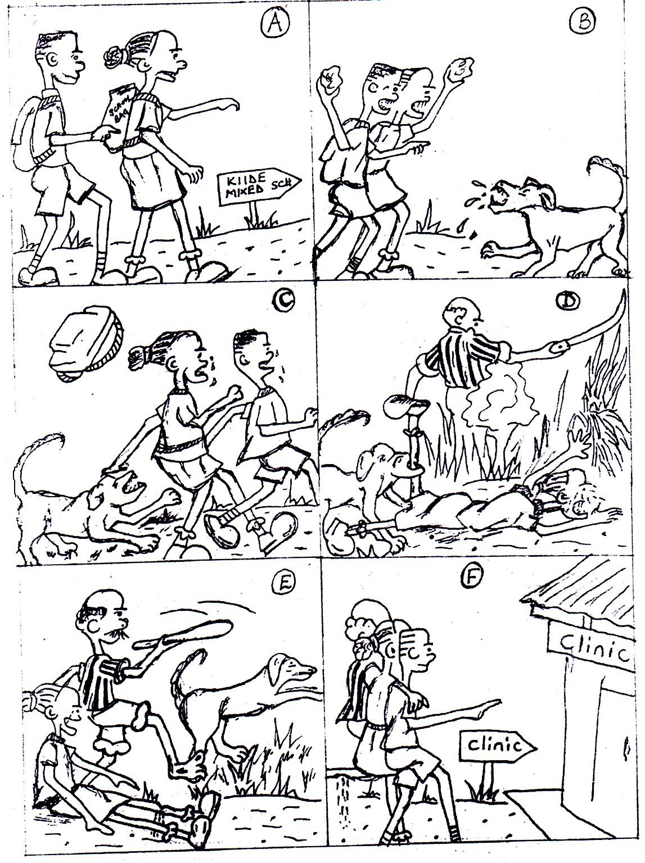
Stoning, going, carrying, biting, chasing, rescuing, approaching, lying

Picture A:

Picture B: Picture C: Picture D: Picture E: Picture F:
i) Where do you think the children were going?

ii) What are the two children in picture “B” doing?

iii) What did the man in picture “E” do?

_

iv) Give a suitable title for the story.

End

